

Ort Braude College

Software Engineering Department

**Innovative supportive social media application for Android users**

In Partial Fulfillment of the Requirements for

Final Project in Software Engineering

(Course 61401) Karmiel – January 2020

**Authors:**

Or Magogi , ID: 204381503

Naor Ohana , ID: 308554815

**Supervisor:**

Mr. Alex Kaselman

**Contents**

1. Introduction…………………………………………………………………………………………….…………..3
   1. Paper organization…………………………………………………………..………………………………….3
2. Background and related work………………………………………………………………………………………3
   1. Current problems
      1. Cyber bullying
      2. Lack of carring
   2. Market research
      1. Heroes for life
      2. Facebook
      3. We heart it
3. Our solution
4. Expected results
5. **INTRODUCTION**

It is well known that social media applications (e.g. Facebook, Instagram, Twitter etc.) have become an integrated part of our lives.

Up until January 2019, 3.26 billion people use social media on mobile devices, with a growth of

297 million new users every year.

From that number of users, we get a very high percentage of 76.67% (October 2019) of Android users.

There is no doubt that social media is a wonderful platform of meeting new friends, staying up to date on world wide issues and so on.

Unfortunately, not all of the published data is appropriate. Some uses of those platforms might be as bad as

cyber harassing, blackmailing, lack of human contact and time wastage.

More over, caring for each other is an essential need for all of us. There are many ways people can help and care for others, but not many people are aware to them.

Thus, to try overcoming these problems, a new innovative application has to take the role of changing our society.

1. **Background and related work**
   1. **Current problems**
      1. **Cyber bullying**

Cyber bullying refers to Internet bullying. It can be done by using technological devices

(e.g. computer, cellphone etc.), to bully or harass another person.

Statistics have shown that cyber bullying has become a serious problem (can be seen in Figure 1) among teenagers, But not only for them.

Cyber bullying can take many forms, such as:

* Mean and offensive messages
* Threats
* Stealing a person’s account

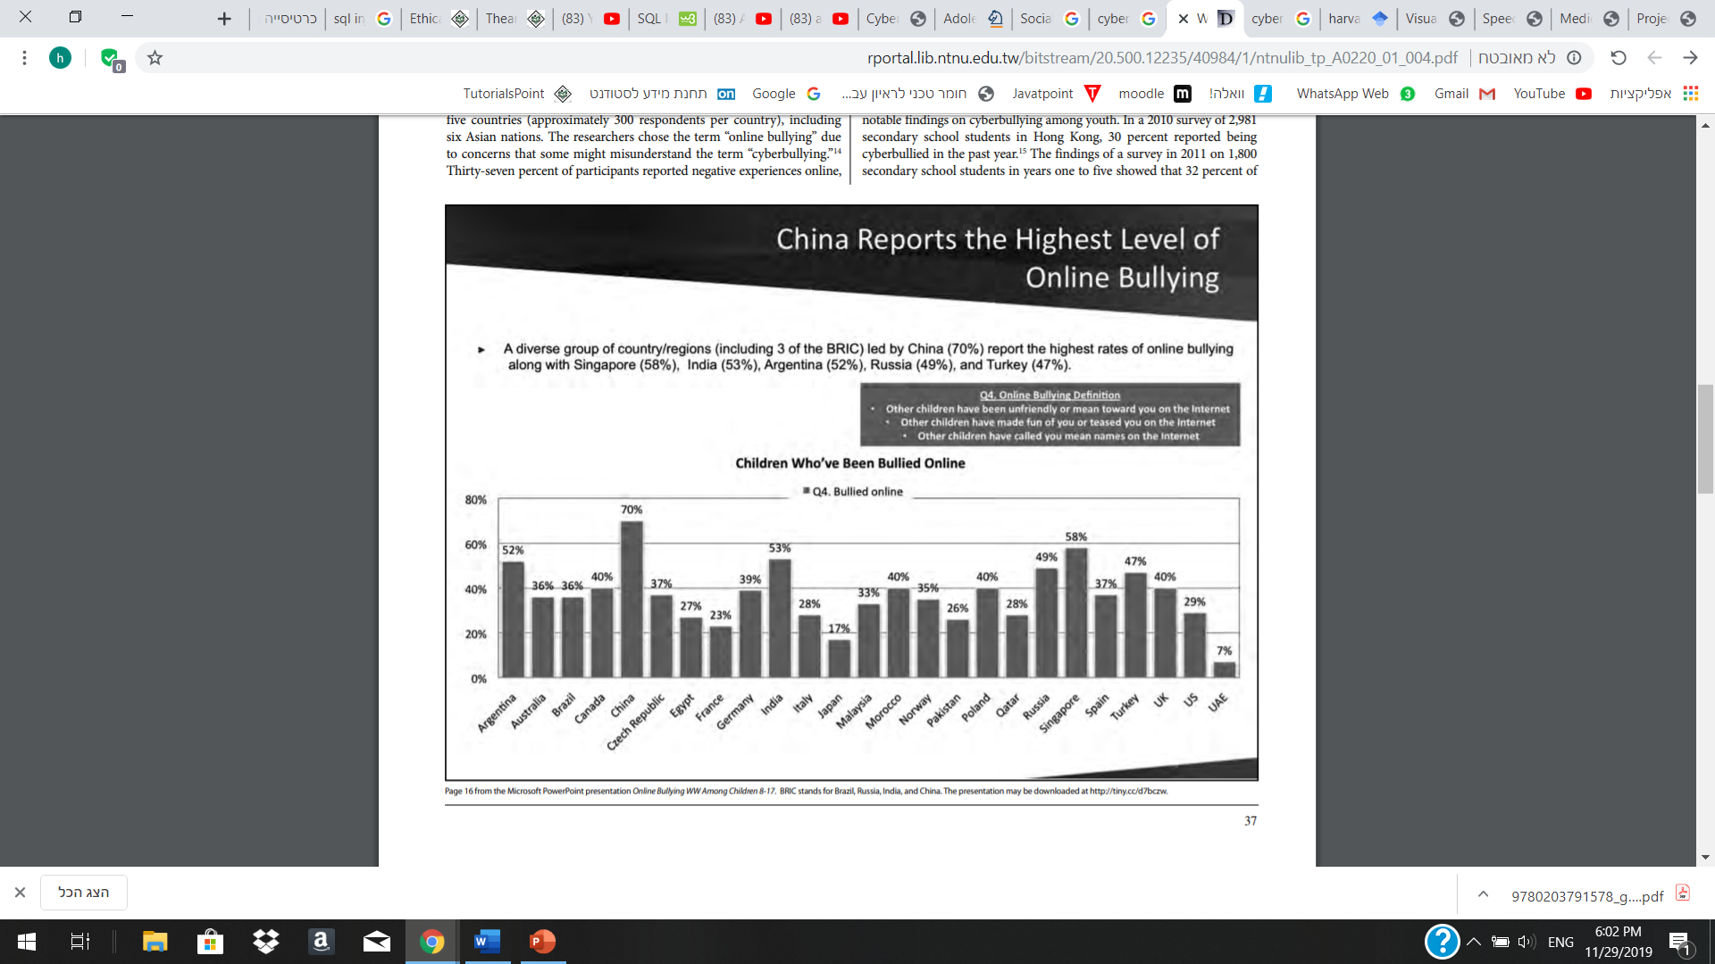

Figure 1: Children around the world who have been bullied online, including: China- 70%, Argentina- 52%, Russia- 49%, from the “Cyber Asia and the New Media” paper, by Christine Suniti Bhat, Shih-Hua Chang, and Moira A. Ragan.

<http://rportal.lib.ntnu.edu.tw/bitstream/20.500.12235/40984/1/ntnulib_tp_A0220_01_004.pdf>

* + 1. **Lack of caring**

The continent decrease in caring for each other, or even our surroundings, is an issue we must deal with.

Caring may be referred in many forms, such as:

* Helping others
* Volunteering
* Saving the environment

Although volunteer work is essential for maintaining a stable and thriving society,

we face a decreasing number of people who are willing to contribute, for others and for the environment we live in. For example, the volunteering rate of 2018 in the United States was 24.9%, compared to 28.8% in 2003-2005 (Figure 2).

According to Amy Yotopoulos, from the Stanford Center On Longevity, three reasons people do not volunteer are:

* They do not have much time
* Lack of information and loss of interest
* No one has asked them to

Although we probably can not influence their time management, we are able to inform them about diverse volunteer opportunities and share all the information they need about the work they are interested in.

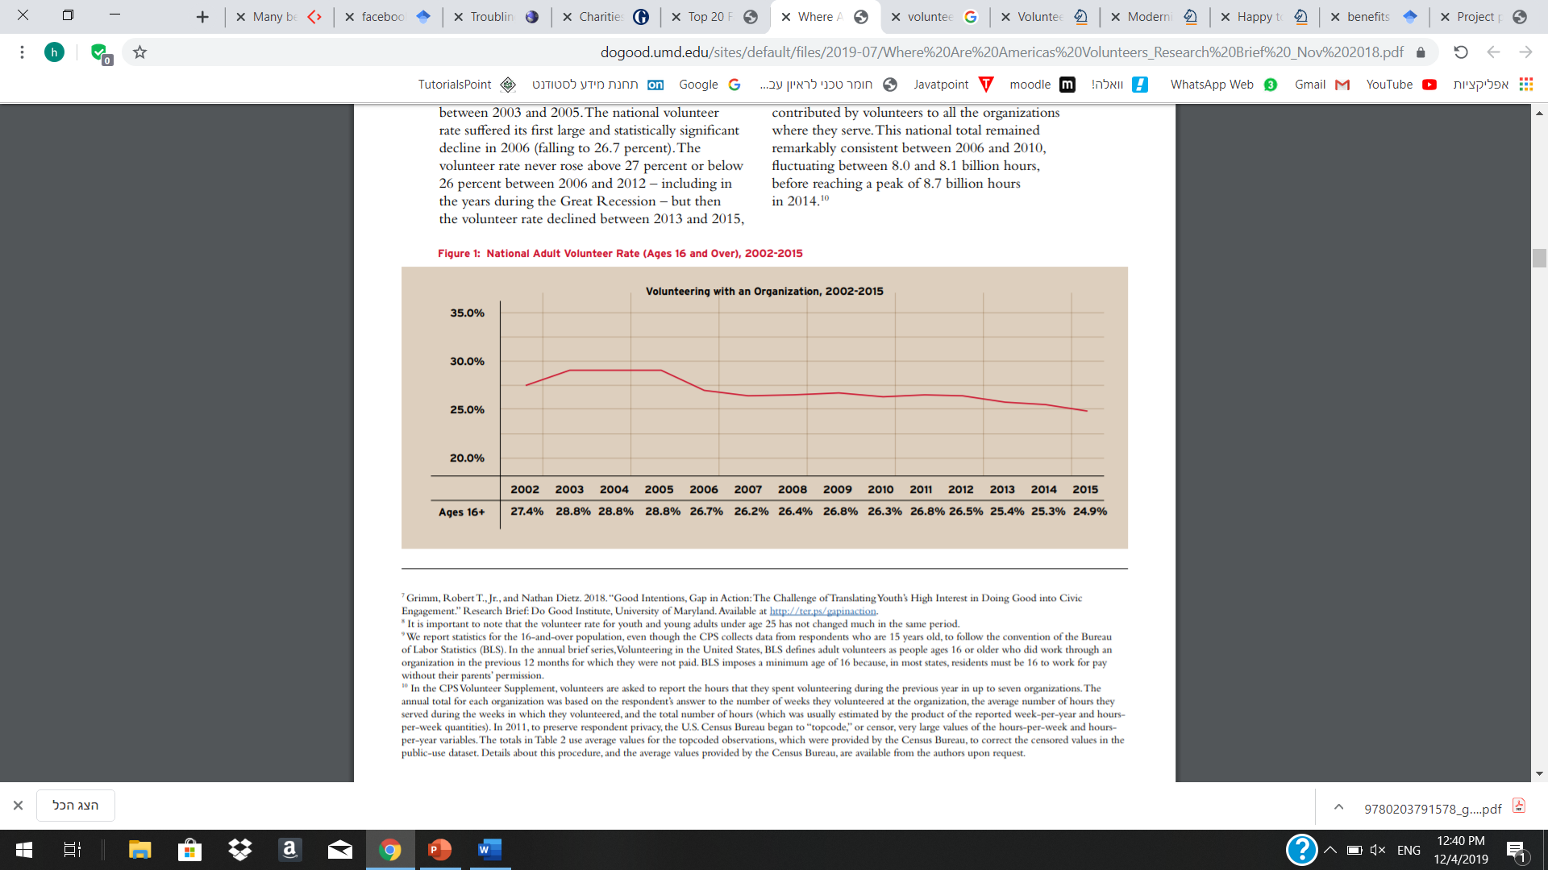

Figure 2: National adult volunteer rate in the United States (Ages 16 and Over), 2002-2015,

from the University of MARYLAND, October 2018

<https://dogood.umd.edu/sites/default/files/2019-07/Where%20Are%20Americas%20Volunteers_Research%20Brief%20_Nov%202018.pdf>

* 1. **Market research**

Currently, there are some famous organizations or applications that may suggest partial solutions for the problems which were discussed above. Let us discuss about those existing solutions and about the reasons we found them to be not completely satisfying:

* + 1. **Heroes for life**

(source) <http://hfl.org.il/en/#delegations>

Background: Heroes for life (i.e. lokhamim le'lo gvulot in Hebrew) was founded in 2013 by three IDF officers who served together in an elite unit. Their vision is to turn Israel into a global superpower of charity in developing countries and to run humanitarian volunteer projects in four different continents of the world. For this purpose, the organization sends delegations of volunteers combined of post- army Israeli travelers to contribute in poor countries, while supplying them food and accommodation during their volunteering time.

Usually the volunteering will be in an orphanage, and will include many different subjects, the main ones being- teaching English, calculus, personal hygiene, values, music and arts, renovating, painting and more.

For the present, 4100 children were assisted, in 4 continents, during 3 years of activity.

Advantages:

* A truly decent opportunity for people who want to volunteer, while travelling the world.
* The organization and its published activities raise the awareness of poor people's problems and somehow manage to achieve caring.
* People who participate the program can meet with other people in the program and make new friendships.
* Volunteers get accommodation and food supply by the organization, while staying abroad.

Disadvantages:

* The volunteering is limited for post-army Israelis and only for certain activities, mainly in poor countries.
* There is no real time help for people who need it on the daily basis.
* The benefit that the volunteers get is limited.
* There is a potential to improve the connection between the volunteers and to make it become a larger, more connected community.
  + 1. **Facebook**

Background: Facebook is one of the most common social medias in the world, with approximately 1.62 billion daily active users (i.e. users who log in every day) as of September 2019. It has begun in February of 2004, as a school-based social network, by Mark Zuckerberg along with Edward Saverin.

Their mission was to give people the power to build community and bring the world closer together. People use Facebook to stay connected with friends and family, to discover what is going on in the world, and to share and express what matters to them.

Advantages:

* Easy way to make new connections, as you can see peoples interests and shared media.
* Publishing may help for business groups
* You can publish your thoughts, help others or ask for help.

Disadvantages:

* Does not encourage enough volunteer work.
* Might have offensive and harmful contents, especially comments and discussions.
* Does not encourage its users to participate in social meetings outdoors.
  + 1. **We Heart It**

<https://en.wikipedia.org/wiki/We_Heart_It>

Background:We Heart It was founded in 2008 by Fabio Giolito, a native of [Brazil](https://en.wikipedia.org/wiki/Brazil). He started the site as a side project around the idea of "hearting" photos and saving them for sharing with friends. In December 2013, We Heart It reached 25 million monthly users. We Heart It is an image-based [social](https://en.wikipedia.org/wiki/Social_media) network. It describes itself as "A home for your inspiration" and a place to "Organize and share the things you love." Users can collect (or "heart") their favorite images to share with friends and organize into collections.

We Heart It is known for its positive community, since there are no features for commenting, users feel more comfortable posting content since it will not receive negative comments as it might on other social networks.

Advantages:

* Users can share and receive photos according to their topics of interest and communicate with other people in same circles of interest.
* Since there are no features for commenting, the topics stay pure and clean of bad discussions or harming comments, therefore the social-network stays more positive.
* Users can find inspiration in the tips and photos that people post and get helped by that.

Disadvantages:

* The application does not encourage volunteering and helping each other enough.
* Users do not get the chance to participate in social events.
  1. **Conclusion**

Nowadays, cyber bullying and harassment are big issues, caring and volunteering rates are decreasing.

There are partially existing solutions for those problems including organizations as Heroes for life and applications as Facebook, We Heart It (and more), but there is no application that takes care of solving all of those on one platform.

1. **Our solution**
   1. **General description of the application**

Our approach is to solve the problems above with a social network application, called “BeSocial”. The application will include features which will support making new connections and sharing information with each other (e.g. posts, picture uploads, messages etc.). In addition, it will also include features which will allow the users to volunteer, get help, see upcoming social or volunteering events.

The application will encourage the users to help others and participate in social events by giving them special benefits- as more they are active, the more they get.

* 1. Better social experience

As in most social networks, our users will be able to upload and share pictures and thoughts, follow and chat with other users. Furthermore, they could be a part of groups according to their interests, getting to know other users with similar interests as theirs. While this being said, "BeSocial" will act to keep the vibes of the social network more positive, by allowing user only to like posts, no comments. We will act as much as possible for not allowing abusive content or abusive users, by removing bad posts and blocking this kind of users. Users will be able to report other users or offensive content, all for making the user's social experience cleaner and more positive.

* 1. More friendship making, volunteering and fun social meetings

Our goal in "BeSocial" is to create a real supportive and friendly community. Therefore, the application will provide a convenient platform to communicate with other users by using chat, to volunteer and get help from others by creating a "Need help" events or searching for other users' events around you. Users will also be able to socialize and meet new people outside of the social network by attending fun social events, organized by event organizers of the company. In order to boost users to participate in the activities of the application, we will use the "social points" and bonuses method. Bonuses will come in form of benefits in selected companies on different categories (e.g. discounts in clothing stores, coffeeshops, movie theaters, sports and etc.). Moreover, selected high ranked users would be able to participate in high-valued events of "BeSocial", such as barbeque events, bar tours, community service volunteer events and even volunteering abroad, all for free or sometimes even getting paid while filling the role of event organizers. As part of the benefits method, users who make "positive" actions such as: connecting other users by sending a message, helping others, participating in social or volunteering events and etc., will be benefitted by receiving "social points". These points are required for level-ups of users' ranks and receiving bonuses, the higher the rank is- the better the available benefits are.

* 1. Farther information about "social points" and bonuses

As explained before, the method of benefits to the users is an important key for our application to boost users helping each other, volunteering and meet. The following paragraphs explains more about this method.

* + 1. Ranks and Points

Users can view their "social points", ranks and benefits in the "bonus area". Here is the list, in escalating order, of the ranks and the defined "social points" that user should have to receive them:

1. "Shy socializer": 0-200 points.

2. "Out of the shell socializer": 201-800 points.

3. "Academic socializer": 801-2600 points

4. "Socialized ninja turtle": 2601-6000 points.

5. "Socialosaurus": 6001 points and on.

* + 1. Ways to receive "social points"

Users would be able to gain "social points" by being active in different ways as the following:

* Start a new conversation with other user- 2 points.
* Help people on "Help me" events- 50 points (limited to up to 3 events per day).
* Contribute in volunteering event-100 points.
* Participate in social event-50 points.

1. **Expected results**

Aiming for achieving our goals, we expect to reach millions of people.

Our application will include features that will encourage our users to make new friendships, mingle with others , meet their friends in person and leave hatred and prejudices aside. It will also push them to be more polite, help others, clean the environment and make a better society.

While doing so, we hope that our users will find joy in contributing, whenever they are rewarded or not.

Our application will host contribution events (e.g. charity work, cleaning beaches etc.) and social events

(e.g. running races, barbeques etc.), as many as it will be able to.

Most importantly, our final and most eminent goal is to make a better society, for a better tomorrow.

1. **Software Engineering Documents**
   1. **Requirements**
   2. **Design**
   3. **Testing plan**

We will perform a series of testing cases, covering a variety of common scenarios of using the application.

The testing plans will ensure the reliability of our system and will prevent uncomfortable situations.

* + 1. Application testing
       1. Registration and login testing

|  |  |  |  |  |
| --- | --- | --- | --- | --- |
| Test name | Description | Expected results | Actual results | Comments |
| False  registration | Choose “Register” option, enter not valid details and press “Register”. | We get a toast, saying the details we entered are not valid. |  |  |
| Complete registration | Choose “Register” option, enter appropriate details and press “Register”. | A feedback is given, a new user is registered in the DB and we are back to login page |  |  |
| False  user login | Try to perform a login with an unregistered user. | We get a toast, saying the username or password are wrong. |  |  |
| Successful user login | Enter registered username and password and press “login”. | The user’s home page is shown on the screen. |  |  |
| Successful manager login | Enter manager’s username and password and press “login”. | Home page is shown, with app manage operations |  |  |

* + - 1. User operations testing

|  |  |  |  |  |
| --- | --- | --- | --- | --- |
| Open “My profile” fragment using menu | Press “My Profile” on menu. | Profile fragment is shown on screen |  |  |
| Open “Home” fragment using menu | Press “Home” on menu. | Homepage fragment is shown on screen |  |  |  |  |
| Open “Chat” fragment using menu | Press “Chat” on menu. | Chat fragment is shown on screen |  |  |
| Open “Social Center” fragment using menu | Press “Social Center” on menu. | Social center fragment is shown on screen |  |  |
| Open “Bonus Area” fragment using menu | Press “Bonus Area on menu. | Bonus area fragment is shown on screen |  |  |
| Open “Settings” fragment using menu | Press “Settings” on menu. | Settings fragment is shown on screen |  |  |
| False change in user settings | Enter settings, press”Edit”, change fields and choose “No” on save dialog. | All previous details are in the fields. |  |  |
| Successful change in user settings | Enter settings, press”Edit”, change fields and choose “Yes” on save dialog. | All new details are in the fields. |  |  |
| Choose category | On home, press a category from the list. | All new posts belong the chosen category. |  |  |
| Enter a user’s profile | On home,choose a post, press it’s user’s profile picture. | The user’s profile page is shown on screen. |  |  |
| Follow user | On a user’s profile, press “Follow” button. | The user’s posts are shown on home, the button appears as “Unfollow” |  |  |
|  |  |  |  |  |
| False logout | Press “Logout” on menu, then press “No” in the dialog. | The user stays logged in, the last page is shown on screen. |  |  |
| Successful logout | Press “Logout” on menu, then press “Yes” in the dialog. | The user is no longer logged in, login page is shown on screen. |  |  |

**TO CHANGE:**

**Sources:**

<https://wearesocial.com/blog/2019/01/digital-2019-global-internet-use-accelerates> - introduction , user numbers

<https://gs.statcounter.com/os-market-share/mobile/worldwide> - Android users percentage

<http://www.bullyingstatistics.org/content/cyber-bullying-statistics.html> - Cyber bullying statistics

<http://rportal.lib.ntnu.edu.tw/bitstream/20.500.12235/40984/1/ntnulib_tp_A0220_01_004.pdf> - Cyber bullying paper(Figure 1 )

<http://longevity.stanford.edu/three-reasons-why-people-dont-volunteer-and-what-can-be-done-about-it/> - why people do not volunteer – Stanford center of longevity